

**ANKARA YILDIRIM BEYAZIT UNIVERSITY**

**BUSINESS SCHOOL**

**DEPARTMENT OF MANAGEMENT INFORMATION SYSTEMS**

**MOBILE RPG GAME**

**SOFTWARE REQUIREMENTS SPECIFICATION**

**DOCUMENT**

Ahmet Boydaş

Veyis Yalpır

Burhan Özen

Cemal Onat Gönül

Aysu Karaarslan

Halit Onur Kara

ANKARA

2020

Contents

**List of Figures v**

**List of Tables v**

**Revision History vi**

**1.** **Introduction 1**

1.1 Purpose 1

1.2 Scope 1

1.3 Definitions, Acronyms and Abbreviations 2

1.4 References 2

1.5 Overview 3

**2.** **Overall Description 3**

2.1 Product Perspective 3

2.1.1 System Interface 4

2.1.2 User Interfaces 4

2.1.3 Hardware Interfaces 4

2.1.4 Software Interfaces 4

2.1.4.1 Server side software 4

2.1.5 Communications Interfaces 5

2.1.6 Memory Constraints 5

2.1.7 Operations 5

2.1.8 Site Adaptation Requirements 6

2.2 Product Functions 6

2.2.1 All Users 6

2.2.2 General Manager 6

2.2.3 Middle-Level Manager 6

2.2.4 Customer 6

2.2.5 Firm 7

2.2.6 System Administrator 7

2.3 User Classes and Characteristics 7

2.3.1 Administrator 8

2.3.2 Customers 8

2.3.3 Firms 8

2.3.4 General Managers 8

2.3.5 Middle-Level Managers 8

2.4 Constraints 8

2.4.1 Regulatory policies; 8

2.4.2 Hardware limitations 8

2.4.3 Interfaces to other applications; 8

2.4.4 Parallel operation; 8

2.4.5 Higher-order language requirements; 8

2.4.6 Reliability requirements; 9

2.4.7 Criticality of the application; 9

2.4.8 Safety and security considerations. 9

2.4.9 Design and Implementation Constraints 9

2.5 Assumptions and Dependencies 9

2.6 Apportioning of requirements 9

2.6.1 User Documentation Requirements 9

**3.** **Specific Requirements 9**

3.1 External Interface Requirements 9

3.1.1.1 User interfaces 10

3.1.1.2 Firm Pages 10

3.1.1.3 Customer Pages 19

3.1.1.4 System Administrators Pages 44

3.1.1.5 General Manager Pages 44

3.1.1.6 Middle-Level Management Operational Pages 44

3.1.2. Hardware Interfaces 44

3.1.3. Software Interfaces 44

3.1.4. Communication Interfaces 44

3.2 Functional Requirements 44

3.2.1 User Class 1 – All Users 44

3.2.2 User Class 2 – Customers 44

3.2.3 User Class 3 – Firms 44

3.2.4 User Class 4 – General Managers 44

3.2.5 User Class 5 – Middle-Level Managers 44

3.2.6 User Class 6 – Administrators 45

3.2.7 User Class Scenarios 45

3.2.7.1 User Class Scenario for Registration, Login and Recovery Password Operations 45

3.2.7.2 User Class Scenario for Customer Requests 46

3.2.7.3 User Class Scenario for Change Profile Settings 49

3.2.7.4 User Class Scenario for Logout 50

3.2.7.5 User Class Scenario for Firm Operations 50

3.2.7.6 User Class Scenario for Vehicle Operations 51

3.2.7.7 User Class Scenario for Middle-level Management Operations 53

3.2.7.8 User Class Scenario for General Management Operations 53

3.2.7.9 User Class Scenario for Reporting 53

3.2 Performance requirements 54

3.3 Logical Database Requirements 54

3.4 Design constraints 54

3.4.7 Standards compliance 54

3.4.7.1 Report Format 54

3.5 Software system attributes 54

3.5.7 Reliability 54

3.5.8 Availability 54

3.5.9 Security 55

3.5.10 Maintainability 55

3.5.11 Portability 55

**4** **Appendixes 56**

Appendix A: Routing Optimization in Transportation Management System 56

Travellıng Salesman Problem 56

Maps and Directions- 56

Appendix B: ER Diagram 57

# List of Figures

Figure 1 TMS Environment 3

Figure 2 Components that used in User Interface Design 4

Figure 3 Customer side map sample 56

Figure 4 Transporter side map sample. 56

# List of Tables

**No table of figures entries found.**

# Revision History

|  |  |  |  |
| --- | --- | --- | --- |
| Name | Date | Reason For Changes | Version |
| TMS | 13.03.2017 | - | 0.1 |
| TMS | 27.03.2017 | Customer and Firm Module update. | 0.5 |
| TMS | 28.04.2017 | Use Cases added |  |

*\*TMS: Transportation Management System*

# Introduction

The following subsections provide an overview of the entire Software Requirements Specification (SRS) document.

## Purpose

The purpose of the RPGGO game project is to enable people to create their own virtual characters and have the role-playing experience on the real world. In this way, people are provided with quick and practical thinking and great contributions are made to their imagination. The purpose of this SRS document is to specify software requirements of the RPGGO software. It is intended to take into account all the functionality of the application. This document has been prepared to indicate system features and to be a guide for users.

## Scope

The purpose of the application is to offer users the opportunity to create characters in the virtual world. In this process, we store the data we receive from users on our server. At the same time, our goal is to provide users with a better experience by improving with the data we use. In this way, users will provide a better and healthier experience.

The application has 5 main modules.

1. **Operations Module:** Check status, register, login, profile, ranks etc.

2. **Management Module:** for General Managers and Administrators and Middle-Level Management to manage and monitor operations

3. **Optimization and Routing Module:** for the core functionalities for minimize cost, and maximize satisfactions for customers and firm’s interactions.

4. **Reporting Module:** Prepare Executive Reports and transactional information and statistics from the past transactions.

5. **API Module:** To integrate with 3rd party applications.

The system also workflow will be given by the acquirer and all management activities will be accomplished by middle-level management team of the company.

## Definitions, Acronyms and Abbreviations

* RPGGO: Role Playing Game GO

## References

* *IEEE Std. 830-1998 - IEEE Recommended Practice for Software Requirements Specifications*

## Overview

The SRS is organized with the IEEE STD 830-1998 and it consists of four main parts; introduction, overall description, specific requirement section and appendixes.

Introduction part includes an overview of the entire SRS. Overall description includes the general factors that affect the product and its requirements. This section does not state specific requirements, just those of background. Specific requirement section contains all the software requirements details. Finally, appendixes include ER diagram of database, system messages and report formats.

# Overall Description

This section will give an overview of the whole system. It will describe what type of the stakeholders that will use the system and what functionality is available for each type. At last, the constraints and assumptions for the system will be presented.

## Product Perspective

RPGGO have advantage of the powerful enterprise technologies in its implementation. The system will be a mobil and web application which developed in **JavaScript and Python Programming Language** .So, development environment will be Windows or Linux.

### User Interfaces

The system is a mobile application. So, the users will connect to system via mobile application and each user have a user name and a password to access to the system and they must login into the system. They can register to the system themselves. All user interfaces are designed to be eye-pleasing.

It is recommended for users to use Android 6.0 and above. All user interfaces include standard user interface components like buttons, textbox and images.

### Hardware Interfaces

The application will be available on Android smartphones. The minimum version currently considered is Android 6.0. It is among our goals in developing a system via web browsers.

### Software Interfaces

#### Server side software

Project has several server side software such as node.js, codeigniter. On mobile side we use react native.

##### Data Layer

On the data side, we are considering progressing through MongoDB or Mysql.

The Database Engine is MySQL Server.

##### Business Logic Layer

On the business logic, Enterprise JavaBean Framework will be used. The framework enables local and remote calls for the system and enable reusability.

##### //Presentation Layer

/////////The presentation layer will be developed with Java Server Faces technology which are widely used in the industry. The component suites that used in the application are Primefaces, Omnifaces, Butterfaces, Bootsfaces and Facelets.

The user interface is on this layer. The user can access any kind of modern browser. Client side software

Web browser supporting JavaScript. The browser should support ECMAScript 5 and IE9+, Firefox 40+, Chrome 30+ browsers.

Compatible operating system: Linux, MacOS, Windows and any OS that enable browsing on the internet.

### Communications Interfaces

//////////HTTP/HTTPS protocols over TCP/IP required for the web browser to access web application interfaces. Also, SMTP client will be used for sending mails to the external interfaces.

* The web pages are present to provide the user interface on customer client side. Communication between customer and server is provided through HTTP/HTTPS protocols.
* The Client Software is to provide the user interface on system user client side and for this TCP/IP protocols are used.
* On the server side web server is Tomcat and MySQL database server is for storing the information.

### Memory Constraints

//////////The web server will work with at least 512 MB available RAM and additional 5GB Hard Drive Memory to store database and other required data.

The client systems need minimum 1GB memory. And Not need to Hard Drive Memory

### Site Adaptation Requirements

All data shall not be deleted on the system permanently because of the operational requirements.

## Product Functions

### All Users

* Login
* Logout
* Change Password
* Recovery Password
* Create Character
* Join a Team
* View Profile

### General Manager

* Dashboard
* Request Reports
* Assign middle-level manager
* Change General System Settings

### Middle-Level Manager

* View Transactions
* See details, interfere to the transactions
* Take feedbacks
* Solve firm’s problems

### Customer

* Submit an Offer
* Make payment
* Review Data
* Help

### System Administrator

* Create Report
* Change Global Settings
* Manage Database
* Manage General Manager roles
* Manage Middle-level managers
* Report logs

## User Classes and Characteristics

* **User Characteristics**
* There are five type of users that interact with the system: RPGGO General Manager, RPGGO Middle Level Managers, firms who provide service for cargos, and customers who want to use cargo firms, And Administrators who is technical personal to manage RPGGO.
* General Managers manage the system’s global configurations, and take reports. Middle-level managers handle customer and firm issues. Customers request new cargo transaction and firms handle the requested cargo operations.
* **User Classes**
* Some of the users identified for this system through use case analysis are listed below:
* - Customers
* - Firms
* - General Managers
* - Administrator
* - Middle-Level Managers

### Administrator

The administrator should be a full time personal who operates and maintains essential parts of infrastructure of the system.

### Customers

The customers are individual or enterprise clients who make spawn request on the systems.

### Firms

The customers are individual or enterprise clients who make spawn request on the systems. They are other type of our customers.

### General Managers

The General Manager is a full-time person who manage middle-level managers and configure system using web application control panel. Also, H/She Can take reports and assign role to the middle-level managers. General Managers also have dashboard provided by the reporting module.

### Middle-Level Managers

The middle-level manager is a person who manage customers and firms on the web application. Solve conflict between firm and customer, and take feedbacks and monitor the issues that occurred on the operations.

## Assumptions and Dependencies

The System will run on Web Server with Internet Connectivity. The user should be  
equipped with GPS Receiver. The administrator will track all the users.

# Specific Requirements

## External Interface Requirements

The following sections will introduce the numerous requirements of the system from the point of view of different users and will introduce several decisions that have been made regarding implementation. These sections also attempt to somewhat describe the role of each user group in the system, discussing their individual roles through the functions they can perform.

### User interfaces

#### Firm Pages

##### Firm Register Page

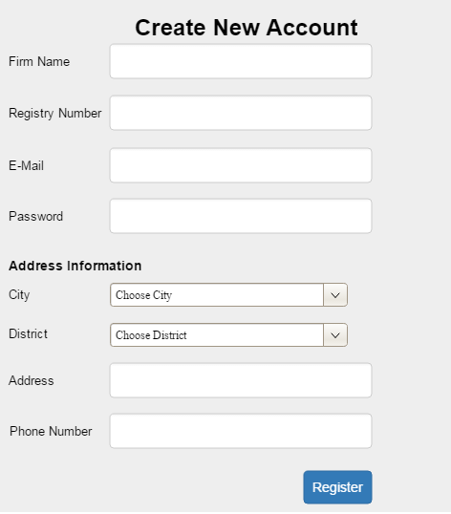

|  |  |
| --- | --- |
| Name of the Item: | Firm Name Text Box |
| Description of Purpose: | To enter the name of the firm |
| Unit of Measure: | Character |
| Source of Input: | Mouse and Keyboard |
| Relationship to other Inputs/Outputs: | It is an input for Register button |

|  |  |
| --- | --- |
| Name of the Item: | Registry Number Input Box |
| Description of Purpose: | To enter the firm’s registry number |
| Unit of Measure: | Character |
| Source of Input: | Mouse and Keyboard |
| Relationship to other Inputs/Outputs: | It is an input for Register button |

|  |  |
| --- | --- |
| Name of the Item: | E-Mail Input Box |
| Description of Purpose: | To enter the e-mail address of the firm |
| Unit of Measure: | Character |
| Source of Input: | Mouse and Keyboard |
| Relationship to other Inputs/Outputs: | It is an input for Register button |

|  |  |
| --- | --- |
| Name of the Item: | Password Input Box |
| Description of Purpose: | To enter the password of the firm (as a user) |
| Unit of Measure: | Character |
| Source of Input: | Mouse and Keyboard |
| Relationship to other Inputs/Outputs: | It is an input for Register button |

|  |  |
| --- | --- |
| Name of the Item: | City Dropdown Menu |
| Description of Purpose: | To choose the city of the firm |
| Unit of Measure: |  |
| Source of Input: | Mouse |
| Relationship to other Inputs/Outputs: | It is an input for Register button |

|  |  |
| --- | --- |
| Name of the Item: | District Dropdown Menu |
| Description of Purpose: | To choose the district of the firm |
| Unit of Measure: |  |
| Source of Input: | Mouse |
| Relationship to other Inputs/Outputs: | It is an input for Register button |

|  |  |
| --- | --- |
| Name of the Item: | Address Input Box |
| Description of Purpose: | To enter the address of the firm |
| Unit of Measure: | Character |
| Source of Input: | Mouse and Keyboard |
| Relationship to other Inputs/Outputs: | It is an input for Register button |

|  |  |
| --- | --- |
| Name of the Item: | Phone Number Input Box |
| Description of Purpose: | To enter the phone number of the firm |
| Unit of Measure: | Character |
| Source of Input: | Mouse and keyboard |
| Relationship to other Inputs/Outputs: | It is an input for Register button |

|  |  |
| --- | --- |
| Name of the Item: | Register Button |
| Description of Purpose: | Gets the user information and register it to the system |
| Source of Input: | Mouse |

##### Firm Login Page

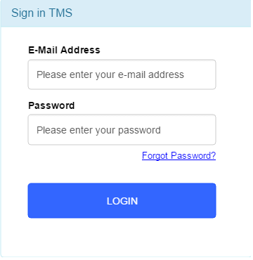

|  |  |
| --- | --- |
| Name of the Item: | E-Mail Address Input Box |
| Description of Purpose: | To enter the e-mail address of the firm |
| Unit of Measure: | Character |
| Source of Input: | Mouse and Keyboard |
| Relationship to other Inputs/Outputs: | It is an input for Login button |

|  |  |
| --- | --- |
| Name of the Item: | Password Input Box |
| Description of Purpose: | To enter the password of the firm (as a user) |
| Unit of Measure: | Character |
| Source of Input: | Mouse and Keyboard |
| Relationship to other Inputs/Outputs: | It is an input for Login button |

|  |  |
| --- | --- |
| Name of the Item: | Forgot Password Link |
| Description of Purpose: | Link to password recovery page |
| Source of Input: | Mouse |

|  |  |
| --- | --- |
| Name of the Item: | Login Button |
| Description of Purpose: | Gets the user id and password and triggers login transaction |
| Source of Input: | Mouse |

##### Firm Update Profile

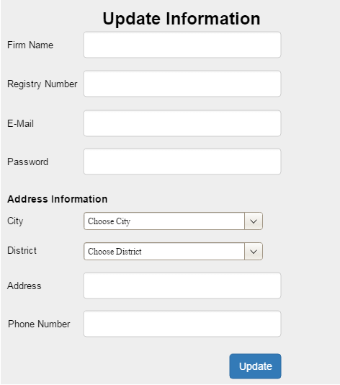

|  |  |
| --- | --- |
| Name of the Item: | Firm Name Text Box |
| Description of Purpose: | To enter the name of the firm |
| Unit of Measure: | Character |
| Source of Input: | Mouse and Keyboard |
| Relationship to other Inputs/Outputs: | It is an input for Update button |

|  |  |
| --- | --- |
| Name of the Item: | Registry Number Input Box |
| Description of Purpose: | To enter the firm’s registry number |
| Unit of Measure: | Character |
| Source of Input: | Mouse and Keyboard |
| Relationship to other Inputs/Outputs: | It is an input for Update button |

|  |  |
| --- | --- |
| Name of the Item: | E-Mail Input Box |
| Description of Purpose: | To enter the e-mail address of the firm |
| Unit of Measure: | Character |
| Source of Input: | Mouse and Keyboard |
| Relationship to other Inputs/Outputs: | It is an input for Update button |

|  |  |
| --- | --- |
| Name of the Item: | Password Input Box |
| Description of Purpose: | To enter the password of the firm (as a user) |
| Unit of Measure: | Character |
| Source of Input: | Mouse and Keyboard |
| Relationship to other Inputs/Outputs: | It is an input for Update button |

|  |  |
| --- | --- |
| Name of the Item: | City Dropdown Menu |
| Description of Purpose: | To choose the city of the firm |
| Unit of Measure: |  |
| Source of Input: | Mouse |
| Relationship to other Inputs/Outputs: | It is an input for Update button |

|  |  |
| --- | --- |
| Name of the Item: | District Dropdown Menu |
| Description of Purpose: | To choose the district of the firm |
| Unit of Measure: |  |
| Source of Input: | Mouse |
| Relationship to other Inputs/Outputs: | It is an input for Update button |

|  |  |
| --- | --- |
| Name of the Item: | Address Input Box |
| Description of Purpose: | To enter the address of the firm |
| Unit of Measure: | Character |
| Source of Input: | Mouse and Keyboard |
| Relationship to other Inputs/Outputs: | It is an input for Update button |

|  |  |
| --- | --- |
| Name of the Item: | Phone Number Input Box |
| Description of Purpose: | To enter the phone number of the firm |
| Unit of Measure: | Character |
| Source of Input: | Mouse and keyboard |
| Relationship to other Inputs/Outputs: | It is an input for Update button |

|  |  |
| --- | --- |
| Name of the Item: | Update Button |
| Description of Purpose: | Gets the user information and update it to the system |
| Source of Input: | Mouse |

##### Firm Dashboard Menu

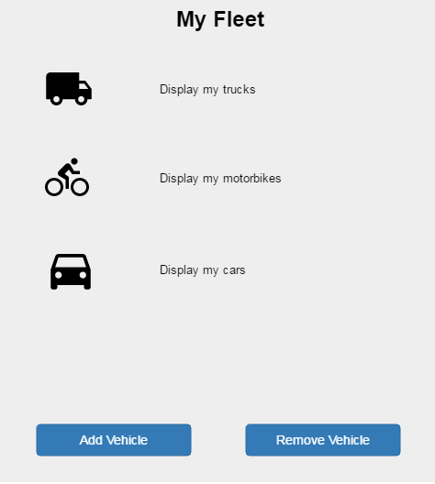

|  |  |
| --- | --- |
| Name of the Item: | Trucks Icon |
| Description of Purpose: | To click to open the trucks page |
| Source of Input: | Mouse |

|  |  |
| --- | --- |
| Name of the Item: | Motorbikes Icon |
| Description of Purpose: | To click to open the motorbikes page |
| Source of Input: | Mouse |

|  |  |
| --- | --- |
| Name of the Item: | Cars Icon |
| Description of Purpose: | To click to open the cars page |
| Source of Input: | Mouse |

|  |  |
| --- | --- |
| Name of the Item: | Add Vehicle Button |
| Description of Purpose: | To click to add vehicle of firm’s fleet |
| Source of Input: | Mouse |

|  |  |
| --- | --- |
| Name of the Item: | Remove Vehicle Button |
| Description of Purpose: | To click to remove vehicle from firm’s fleet |
| Source of Input: | Mouse |

##### New Vehicle Add Screen

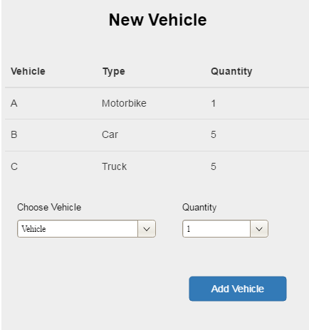

|  |  |
| --- | --- |
| Name of the Item: | Choose Vehicle Dropdown Menu |
| Description of Purpose: | To choose vehicle to add firm’s fleet |
| Unit of Measure: |  |
| Source of Input: | Mouse |
| Relationship to other Inputs/Outputs: | It is an input for Add Vehicle button |

|  |  |
| --- | --- |
| Name of the Item: | Quantity Dropdown Menu |
| Description of Purpose: | To choose quantity of vehicle |
| Unit of Measure: |  |
| Source of Input: | Mouse |
| Relationship to other Inputs/Outputs: | It is an input for Add Vehicle button |

|  |  |
| --- | --- |
| Name of the Item: | Add Vehicle Button |
| Description of Purpose: | To add vehicle of firm’s fleet |
| Source of Input: | Mouse |

##### Update Vehicle Screen

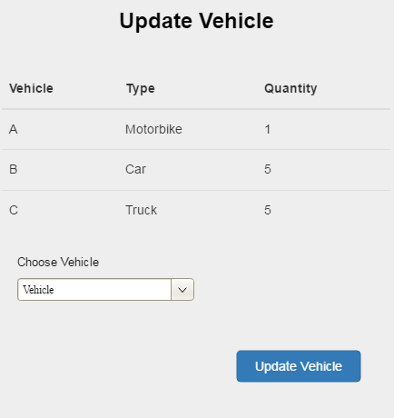

|  |  |
| --- | --- |
| Name of the Item: | Choose Vehicle Dropdown Menu |
| Description of Purpose: | To choose vehicle to add firm’s fleet |
| Unit of Measure: |  |
| Source of Input: | Mouse |
| Relationship to other Inputs/Outputs: | It is an input for Update Vehicle button |

|  |  |
| --- | --- |
| Name of the Item: | Update Vehicle Button |
| Description of Purpose: | To update vehicle of firm’s fleet |
| Source of Input: | Mouse |

#### Customer Pages

##### Customer Register Page

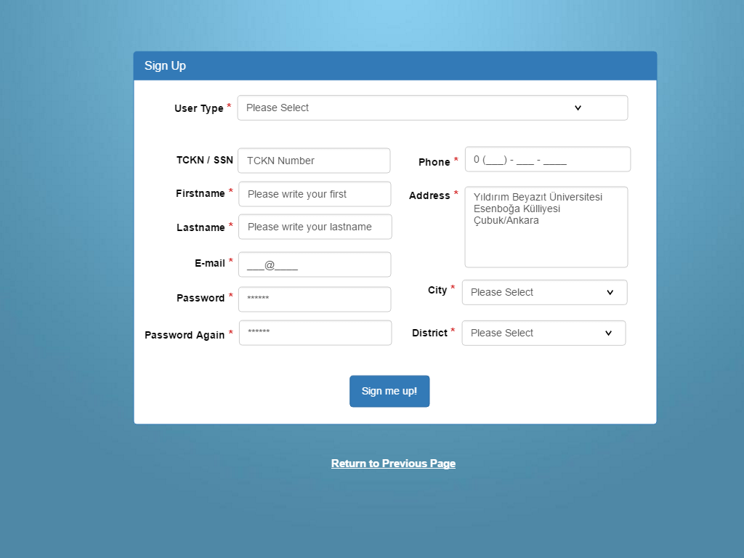

|  |  |
| --- | --- |
| Name of the Item: | Customer Name Text Box |
| Description of Purpose: | To enter the name of the Customer |
| Unit of Measure: | Character |
| Source of Input: | Mouse and Keyboard |
| Relationship to other Inputs/Outputs: | It is an input for Register button |

|  |  |
| --- | --- |
| Name of the Item: | User Type Dropdown |
| Description of Purpose: | To choose the user type individual or enterprise |
| Unit of Measure: | NA |
| Source of Input: | Mouse |
| Relationship to other Inputs/Outputs: | It is an input for Register button |

|  |  |
| --- | --- |
| Name of the Item: | TCKN Number Input Box |
| Description of Purpose: | To enter the Customer’s TCKN number |
| Unit of Measure: | Character |
| Source of Input: | Mouse and Keyboard |
| Relationship to other Inputs/Outputs: | It is an input for Register button |

|  |  |
| --- | --- |
| Name of the Item: | E-Mail Input Box |
| Description of Purpose: | To enter the e-mail address of the Customer |
| Unit of Measure: | Character |
| Source of Input: | Mouse and Keyboard |
| Relationship to other Inputs/Outputs: | It is an input for Register button |

|  |  |
| --- | --- |
| Name of the Item: | Password Input Box |
| Description of Purpose: | To enter the password of the Customer (as a user) |
| Unit of Measure: | Character |
| Source of Input: | Mouse and Keyboard |
| Relationship to other Inputs/Outputs: | It is an input for Register button |

|  |  |
| --- | --- |
| Name of the Item: | City Dropdown Menu |
| Description of Purpose: | To choose the city of the Customer |
| Unit of Measure: |  |
| Source of Input: | Mouse |
| Relationship to other Inputs/Outputs: | It is an input for Register button |

|  |  |
| --- | --- |
| Name of the Item: | District Dropdown Menu |
| Description of Purpose: | To choose the district of the Customer |
| Unit of Measure: | NA |
| Source of Input: | Mouse |
| Relationship to other Inputs/Outputs: | It is an input for Register button |

|  |  |
| --- | --- |
| Name of the Item: | Address Input Box |
| Description of Purpose: | To enter the address of the Customer |
| Unit of Measure: | Character |
| Source of Input: | Mouse and Keyboard |
| Relationship to other Inputs/Outputs: | It is an input for Register button |

|  |  |
| --- | --- |
| Name of the Item: | Phone Number Input Box |
| Description of Purpose: | To enter the phone number of the Customer |
| Unit of Measure: | Character |
| Source of Input: | Mouse and keyboard |
| Relationship to other Inputs/Outputs: | It is an input for Register button |

|  |  |
| --- | --- |
| Name of the Item: | Register Button |
| Description of Purpose: | Gets the user information and register it to the system |
| Source of Input: | Mouse |

|  |  |
| --- | --- |
| Name of the Item: | Return to the previous page link |
| Description of Purpose: | Return to the login page. |
| Source of Input: | Mouse |

##### Customer Register Confirm Page

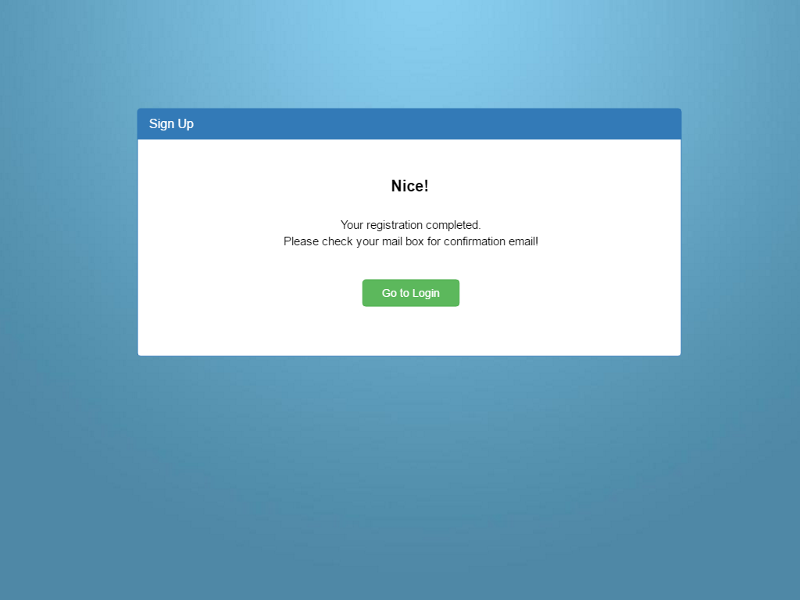

|  |  |
| --- | --- |
| Name of the Item: | Go to Login Button |
| Description of Purpose: | Return to the login page. |
| Source of Input: | Mouse |

##### Customer Login Page

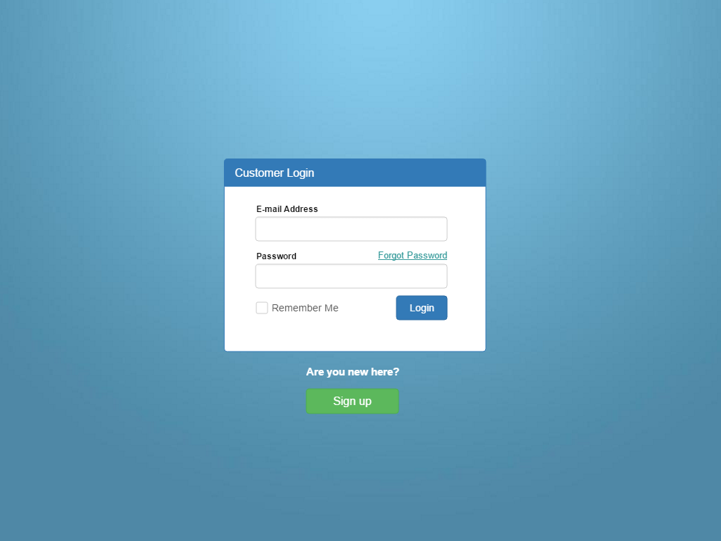

|  |  |
| --- | --- |
| Name of the Item: | E-Mail Address Input Box |
| Description of Purpose: | To enter the e-mail address of the Customer |
| Unit of Measure: | Character |
| Source of Input: | Mouse and Keyboard |
| Relationship to other Inputs/Outputs: | It is an input for Login button |
|  |  |

|  |  |
| --- | --- |
| NName of the Item: | Sign up button |
| Description of Purpose: | Go to the registration page |
| Source of Input: | Mouse |

|  |  |
| --- | --- |
| Name of the Item: | Password Input Box |
| Description of Purpose: | To enter the password of the Customer (as a user) |
| Unit of Measure: | Character |
| Source of Input: | Mouse and Keyboard |
| Relationship to other Inputs/Outputs: | It is an input for Login button |

|  |  |
| --- | --- |
| NName of the Item: | Forgot Password Link |
| Description of Purpose: | Link to password recovery page |
| Source of Input: | Mouse |

|  |  |
| --- | --- |
| NName of the Item: | Login Button |
| Description of Purpose: | Gets the user id and password and triggers login transaction |
| Source of Input: | Mouse |

##### Customer Forgot Password Page

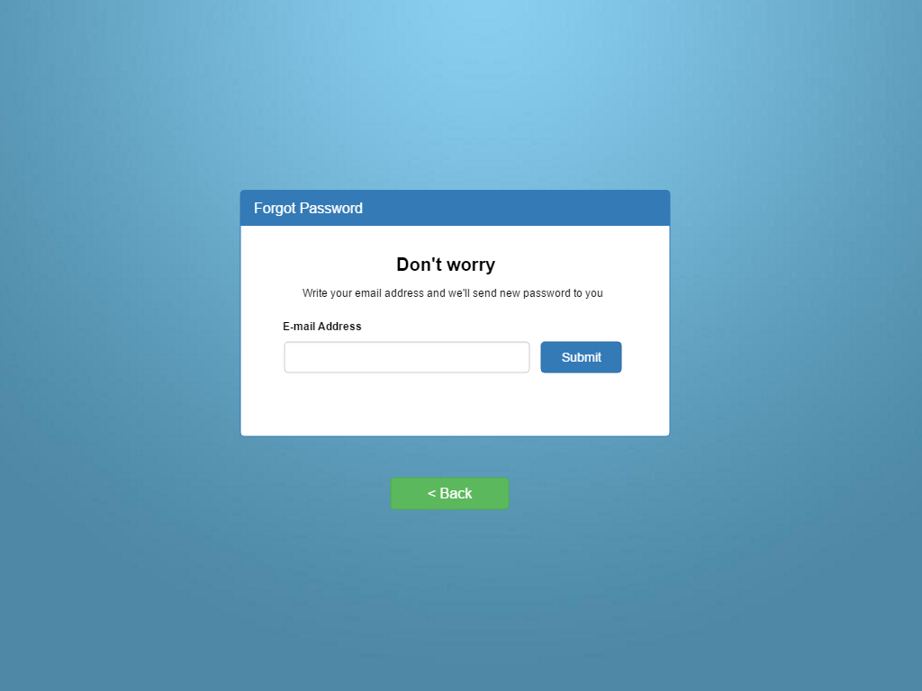

|  |  |
| --- | --- |
| Name of the Item: | E-Mail Address Input Box |
| Description of Purpose: | To enter the e-mail address of the customer |
| Unit of Measure: | Character |
| Source of Input: | Mouse and Keyboard |
| Relationship to other Inputs/Outputs: | It is an input for Login button |

|  |  |
| --- | --- |
| Name of the Item: | Submit Button |
| Description of Purpose: | Complete request new password from the system |
| Source of Input: | Mouse |

|  |  |
| --- | --- |
| Name of the Item: | Back Button |
| Description of Purpose: | Go to login page |
| Source of Input: | Mouse |

##### Customer Forgot Password Confirm

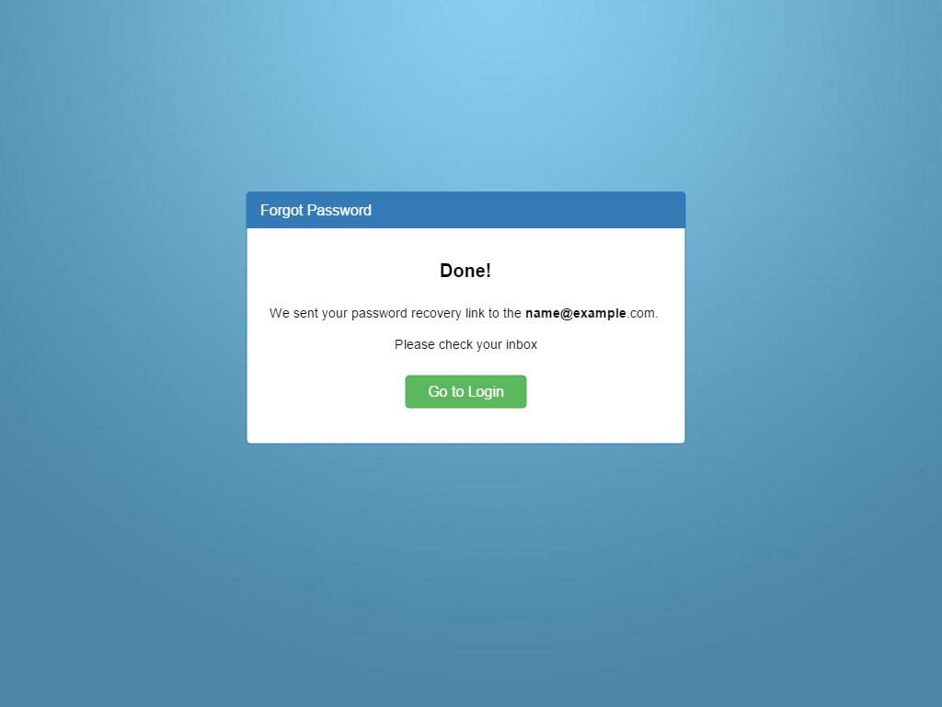

|  |  |
| --- | --- |
| Name of the Item: | Go to Login Button |
| Description of Purpose: | Go to login page |
| Source of Input: | Mouse |

##### Customer Profile Page

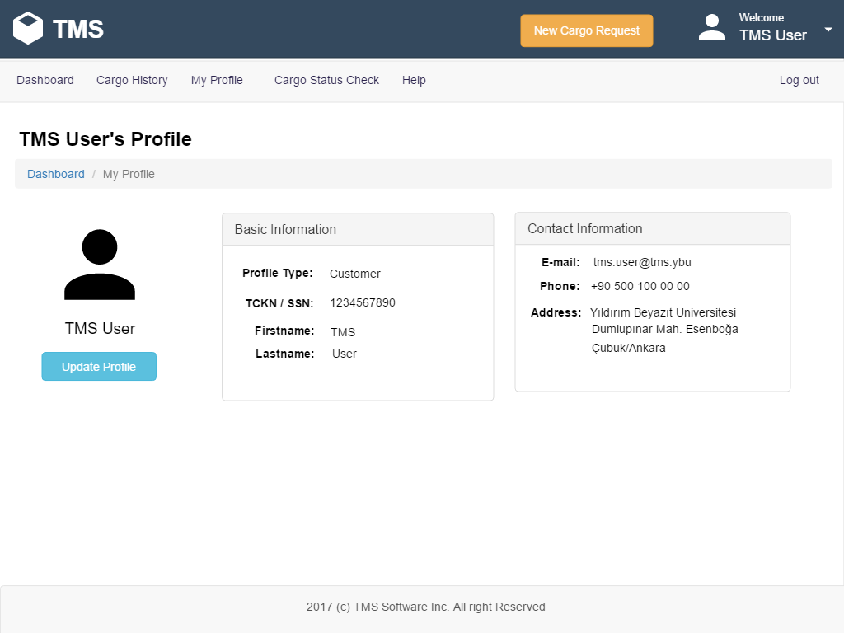

|  |  |
| --- | --- |
| Name of the Item: | TMS Logo |
| Description of Purpose: | Go to Dashboard |
| Source of Input: | Mouse |

|  |  |
| --- | --- |
| Name of the Item: | New Cargo Request Button |
| Description of Purpose: | Go to new Cargo Calculation Page |
| Source of Input: | Mouse |

|  |  |
| --- | --- |
| Name of the Item: | Welcome “TMS User” Link |
| Description of Purpose: | Go to Customer Profile Page |
| Source of Input: | Mouse |

|  |  |
| --- | --- |
| Name of the Item: | Dashboard Link |
| Description of Purpose: | Go to Customer Dashboard |
| Source of Input: | Mouse |

|  |  |
| --- | --- |
| Name of the Item: | Cargo History Link |
| Description of Purpose: | Go to Customer Cargo History Page |
| Source of Input: | Mouse |

|  |  |
| --- | --- |
| Name of the Item: | My Profile Link |
| Description of Purpose: | Go to Customer Profile Page |
| Source of Input: | Mouse |

|  |  |
| --- | --- |
| Name of the Item: | Check Cargo Status Link |
| Description of Purpose: | Go to Cargo Status Check Page |
| Source of Input: | Mouse |

|  |  |
| --- | --- |
| Name of the Item: | Help Link |
| Description of Purpose: | Go to Help Page |
| Source of Input: | Mouse |

|  |  |
| --- | --- |
| Name of the Item: | Logout Button |
| Description of Purpose: | Logout From the System |
| Source of Input: | Mouse |

|  |  |
| --- | --- |
| Name of the Item: | Update Profile Button |
| Description of Purpose: | Go to Customer Profile Update Page |
| Source of Input: | Mouse |

##### Customer Update Profile Page

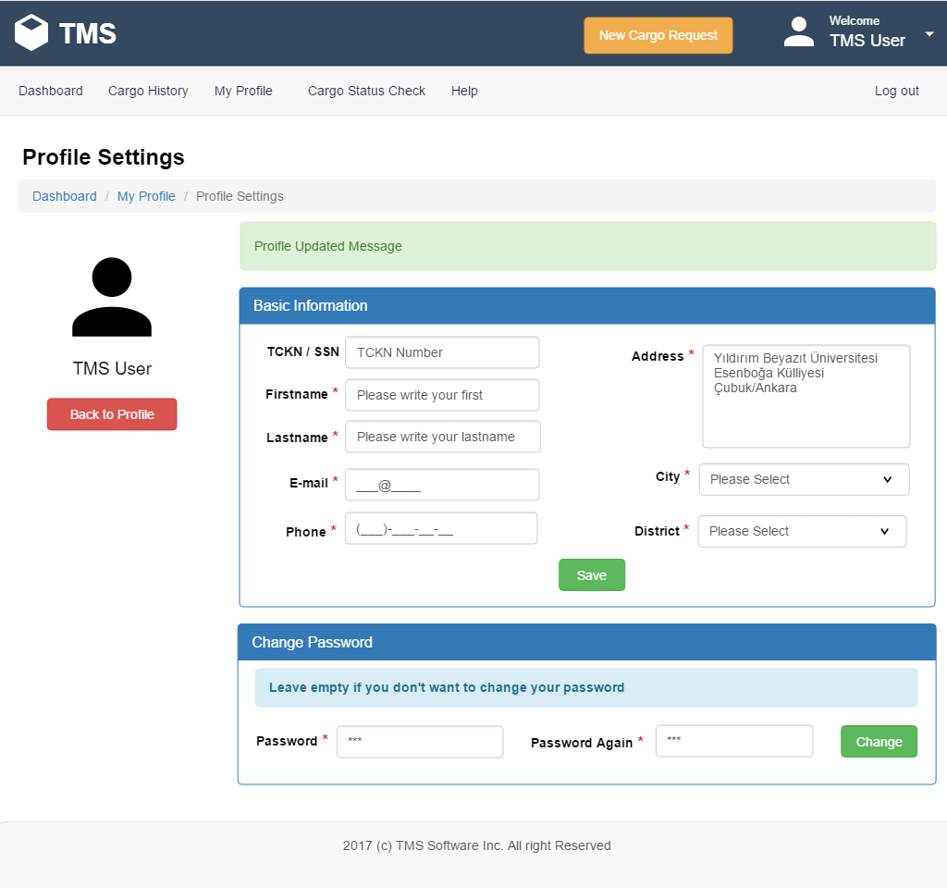

|  |  |
| --- | --- |
| Name of the Item: | Customer Name Text Box |
| Description of Purpose: | To enter the name of the Customer |
| Unit of Measure: | Character |
| Source of Input: | Mouse and Keyboard |
| Relationship to other Inputs/Outputs: | It is an input for Register button |

|  |  |
| --- | --- |
| Name of the Item: | TCKN Number Input Box |
| Description of Purpose: | To enter the Customer’s TCKN number |
| Unit of Measure: | Character |
| Source of Input: | Mouse and Keyboard |
| Relationship to other Inputs/Outputs: | It is an input for Register button |

|  |  |
| --- | --- |
| Name of the Item: | E-Mail Input Box |
| Description of Purpose: | To enter the e-mail address of the Customer |
| Unit of Measure: | Character |
| Source of Input: | Mouse and Keyboard |
| Relationship to other Inputs/Outputs: | It is an input for Register button |

|  |  |
| --- | --- |
| Name of the Item: | Password Input Box |
| Description of Purpose: | To enter the password of the Customer (as a user) |
| Unit of Measure: | Character |
| Source of Input: | Mouse and Keyboard |
| Relationship to other Inputs/Outputs: | It is an input for Register button |

|  |  |
| --- | --- |
| Name of the Item: | Password Confirm Input Box |
| Description of Purpose: | To enter the password of the Customer (as a user) |
| Unit of Measure: | Character |
| Source of Input: | Mouse and Keyboard |
| Relationship to other Inputs/Outputs: | It is an input for Register button |

|  |  |
| --- | --- |
| Name of the Item: | City Dropdown Menu |
| Description of Purpose: | To choose the city of the Customer |
| Unit of Measure: |  |
| Source of Input: | Mouse |
| Relationship to other Inputs/Outputs: | It is an input for Register button |

|  |  |
| --- | --- |
| Name of the Item: | District Dropdown Menu |
| Description of Purpose: | To choose the district of the Customer |
| Unit of Measure: |  |
| Source of Input: | Mouse |
| Relationship to other Inputs/Outputs: | It is an input for Register button |

|  |  |
| --- | --- |
| Name of the Item: | Address Input Box |
| Description of Purpose: | To enter the address of the Customer |
| Unit of Measure: | Character |
| Source of Input: | Mouse and Keyboard |
| Relationship to other Inputs/Outputs: | It is an input for Register button |

|  |  |
| --- | --- |
| Name of the Item: | Phone Number Input Box |
| Description of Purpose: | To enter the phone number of the Customer |
| Unit of Measure: | Character |
| Source of Input: | Mouse and keyboard |
| Relationship to other Inputs/Outputs: | It is an input for Register button |

|  |  |
| --- | --- |
| Name of the Item: | Update Profile Button |
| Description of Purpose: | Save new values for customer to the system. |
| Source of Input: | Mouse |

|  |  |
| --- | --- |
| Name of the Item: | Back to Profile Button |
| Description of Purpose: | Return to customer profile page |
| Source of Input: | Mouse |

|  |  |
| --- | --- |
| Name of the Item: | Change Button |
| Description of Purpose: | Change new entered password for the customer. |
| Source of Input: | Mouse |

##### See Customer Cargo History Page

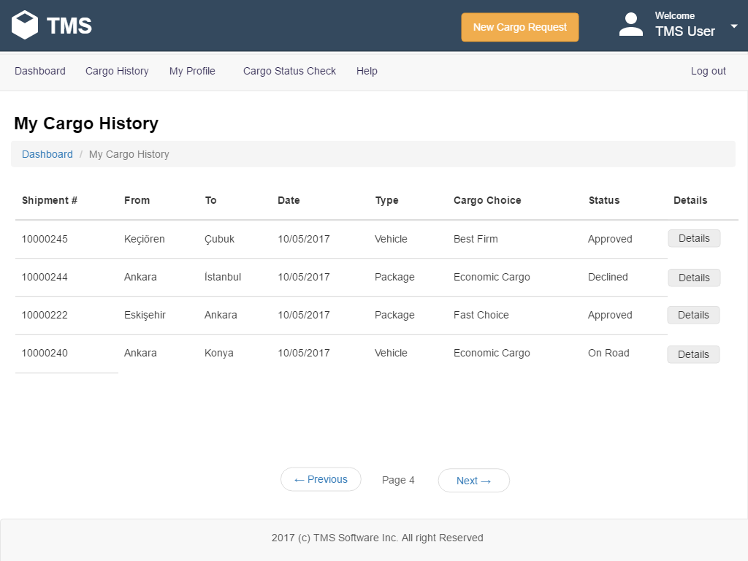

|  |  |
| --- | --- |
| Name of the Item: | Details Button |
| Description of Purpose: | Go to Cargo Details page for specific cargo |
| Source of Input: | Mouse |

##### Cargo Details Page

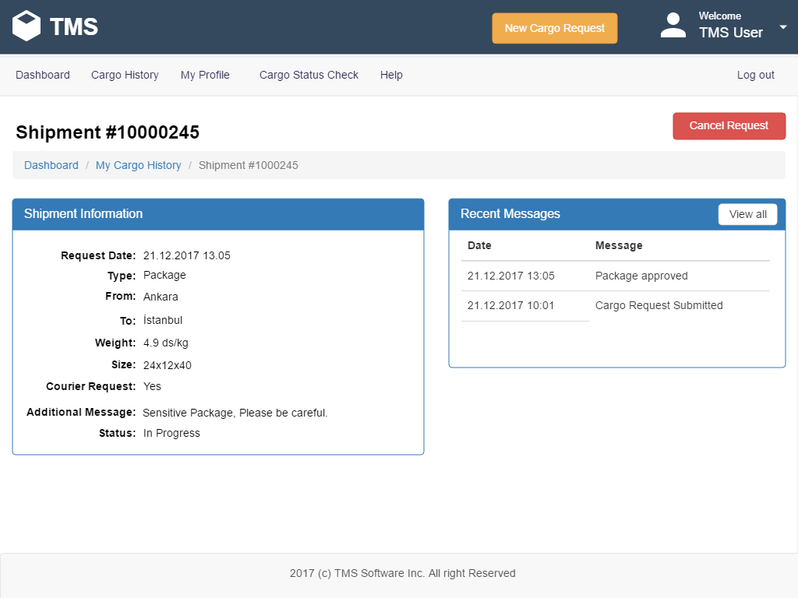

|  |  |
| --- | --- |
| Name of the Item: | Cancel Request Button |
| Description of Purpose: | If the firm don’t handle this request. User can cancel the cargo request for shipment. |
| Source of Input: | Mouse |

|  |  |
| --- | --- |
| Name of the Item: | View All Button |
| Description of Purpose: | Show all message logs for the specific cargo. |
| Source of Input: | Mouse |

##### Cargo Request: Calculation Page

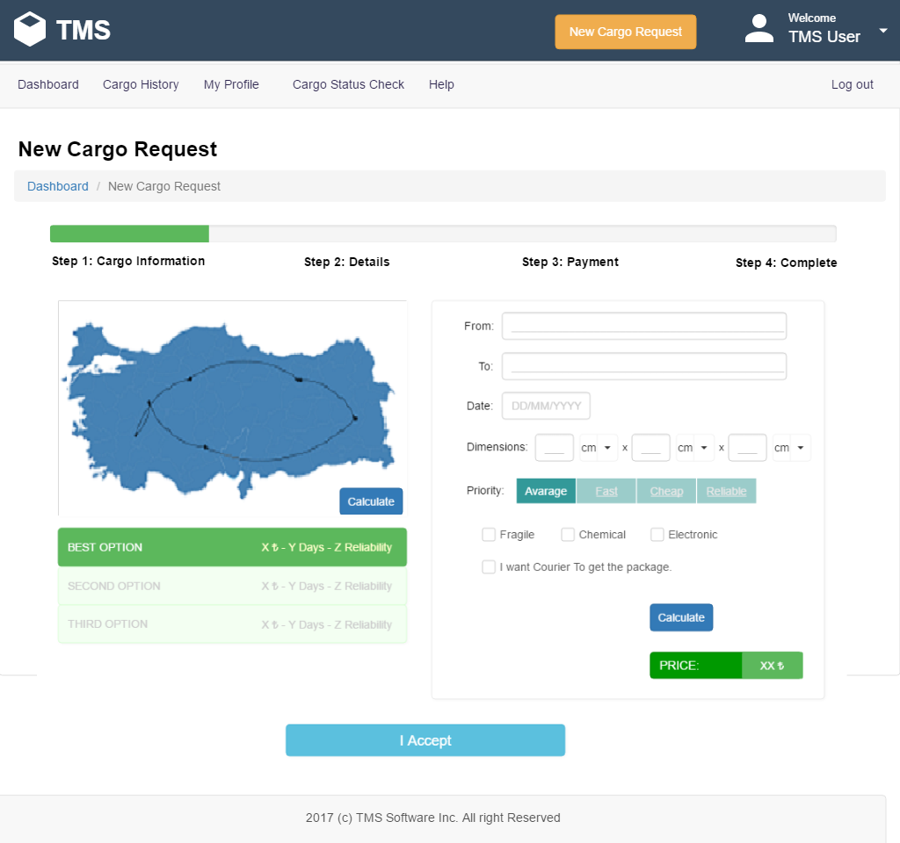

|  |  |
| --- | --- |
| Name of the Item: | Calculate Button on Map |
| Description of Purpose: | Refresh Map for the movement |
| Source of Input: | Mouse |

|  |  |
| --- | --- |
| Name of the Item: | Calculate Button on Right |
| Description of Purpose: | Calculate new price for given parameters. |
| Source of Input: | Mouse |

|  |  |
| --- | --- |
| Name of the Item: | From Input Box |
| Description of Purpose: | Cargo forwarding location |
| Unit of Measure: | Character |
| Source of Input: | Mouse and Keyboard |
| Relationship to other Inputs/Outputs: | It is an input for calculation button |

|  |  |
| --- | --- |
| Name of the Item: | To Input Box |
| Description of Purpose: | Cargo arrival location |
| Unit of Measure: | Character |
| Source of Input: | Mouse and Keyboard |
| Relationship to other Inputs/Outputs: | It is an input for calculation button |

|  |  |
| --- | --- |
| Name of the Item: | Date Input Box |
| Description of Purpose: | Cargo forwarding date |
| Unit of Measure: | Character |
| Source of Input: | Mouse and Keyboard |
| Relationship to other Inputs/Outputs: | It is an input for calculation button |

|  |  |
| --- | --- |
| Name of the Item: | Date Input Box |
| Description of Purpose: | Cargo forwarding date |
| Unit of Measure: | Character |
| Source of Input: | Mouse and Keyboard |
| Relationship to other Inputs/Outputs: | It is an input for calculation button |

|  |  |
| --- | --- |
| Name of the Item: | Priority Radio Buttons |
| Description of Purpose: | Cargo sending option |
| Unit of Measure: | Character |
| Source of Input: | Mouse and Keyboard |
| Relationship to other Inputs/Outputs: | It is an input for calculation button |

|  |  |
| --- | --- |
| Name of the Item: | Dimensions Input Box |
| Description of Purpose: | Cargo package sizes. |
| Unit of Measure: | Character |
| Source of Input: | Mouse and Keyboard |
| Relationship to other Inputs/Outputs: | It is an input for calculation button |

|  |  |
| --- | --- |
| Name of the Item: | Best Option Button |
| Description of Purpose: | Select best option for the cargo |
| Source of Input: | Mouse |

|  |  |
| --- | --- |
| Name of the Item: | Second Option Button |
| Description of Purpose: | Select Second option for the cargo |
| Source of Input: | Mouse |

|  |  |
| --- | --- |
| Name of the Item: | Third Option Button |
| Description of Purpose: | Select Third option for the cargo |
| Source of Input: | Mouse |

|  |  |
| --- | --- |
| Name of the Item: | I Accept Button |
| Description of Purpose: | Select option and continue to the details and payment pages. |
| Source of Input: | Mouse |

##### Cargo Request: Details Page

The page will be designed again.

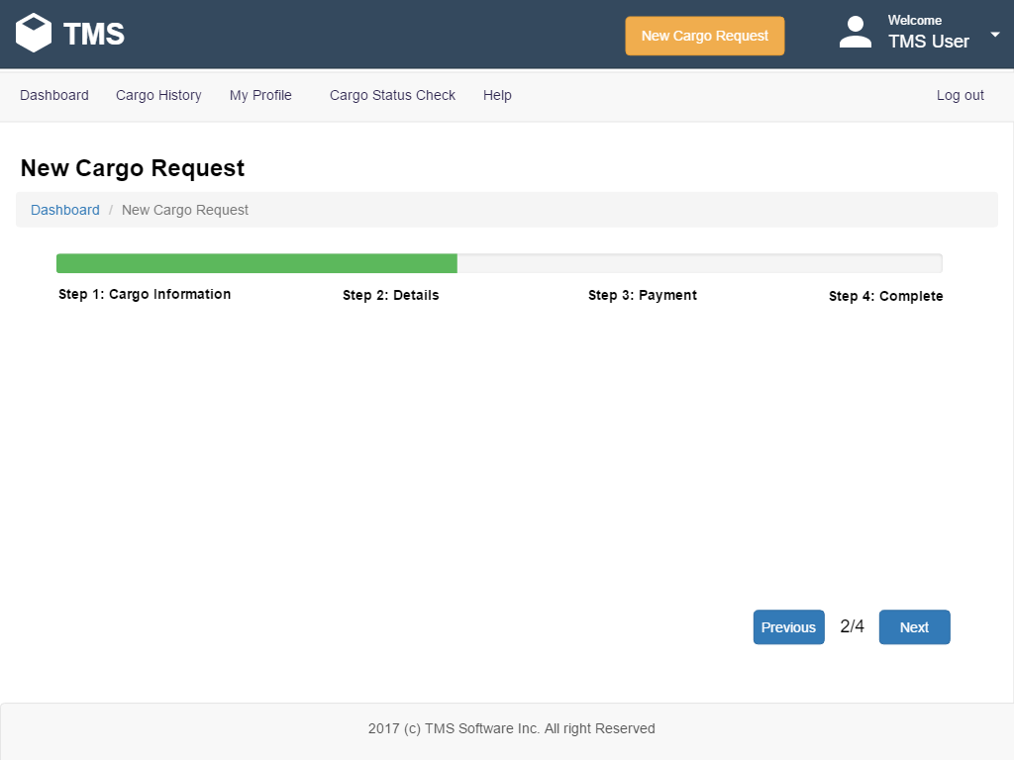

|  |  |
| --- | --- |
| Name of the Item: | Previous Button |
| Description of Purpose: | Go to Step 1: Cargo Information Tab. |
| Source of Input: | Mouse |

|  |  |
| --- | --- |
| Name of the Item: | Next Button |
| Description of Purpose: | Go to Step 3: Payment Tab. |
| Source of Input: | Mouse |

##### Cargo Request: Payment Page

###### Cargo Request: Payment Page – Credit Card option

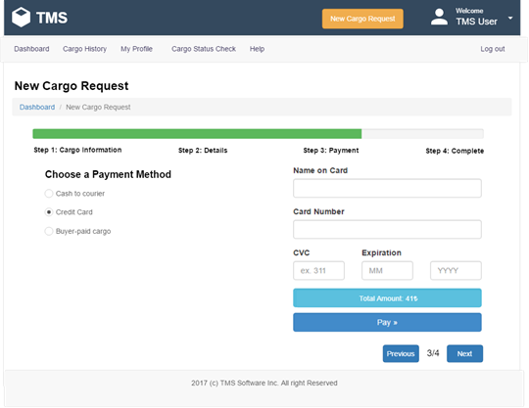

|  |  |
| --- | --- |
| Name of the Item: | Previous Button |
| Description of Purpose: | Go to Step 2: Details Tab. |
| Source of Input: | Mouse |

|  |  |
| --- | --- |
| Name of the Item: | Next Button |
| Description of Purpose: | Go to Step 4: Confirm Tab. |
| Source of Input: | Mouse |

|  |  |
| --- | --- |
| Name of the Item: | Name on Card Input Box |
| Description of Purpose: | Credit Card Owner Name |
| Unit of Measure: | Character |
| Source of Input: | Mouse and Keyboard |
| Relationship to other Inputs/Outputs: | It is an input for pay button |

|  |  |
| --- | --- |
| Name of the Item: | Credit Card Number Input Box |
| Description of Purpose: | Credit Card Number |
| Unit of Measure: | Character |
| Source of Input: | Mouse and Keyboard |
| Relationship to other Inputs/Outputs: | It is an input for pay button |

|  |  |
| --- | --- |
| Name of the Item: | CVC Input Box |
| Description of Purpose: | CVC number for the credit card |
| Unit of Measure: | Character |
| Source of Input: | Mouse and Keyboard |
| Relationship to other Inputs/Outputs: | It is an input for pay button |

|  |  |
| --- | --- |
| Name of the Item: | Expiration Month Input Box |
| Description of Purpose: | Credit Card Expiration Date’s month. |
| Unit of Measure: | Character |
| Source of Input: | Mouse and Keyboard |
| Relationship to other Inputs/Outputs: | It is an input for pay button |

|  |  |
| --- | --- |
| Name of the Item: | Expiration Year Input Box |
| Description of Purpose: | Credit Card Expiration Date’s year. |
| Unit of Measure: | Character |
| Source of Input: | Mouse and Keyboard |
| Relationship to other Inputs/Outputs: | It is an input for pay button |

|  |  |
| --- | --- |
| Name of the Item: | Pay button |
| Description of Purpose: | Select |
| Source of Input: | Mouse |

###### Cargo Request: Payment Page – Cash option

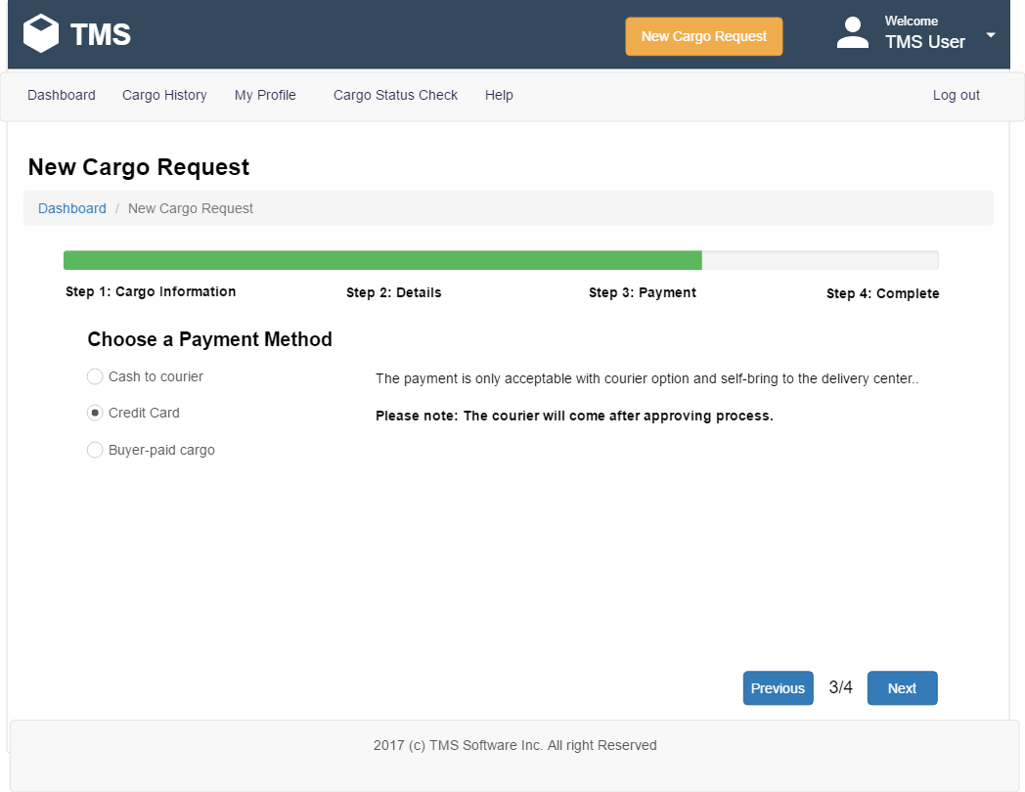

|  |  |
| --- | --- |
| Name of the Item: | Previous Button |
| Description of Purpose: | Go to Step 1: Details Tab. |
| Source of Input: | Mouse |

|  |  |
| --- | --- |
| Name of the Item: | Next Button |
| Description of Purpose: | Go to Step 3: Payment Tab. |
| Source of Input: | Mouse |

###### Cargo Request: Payment Page – Buyer-paid option

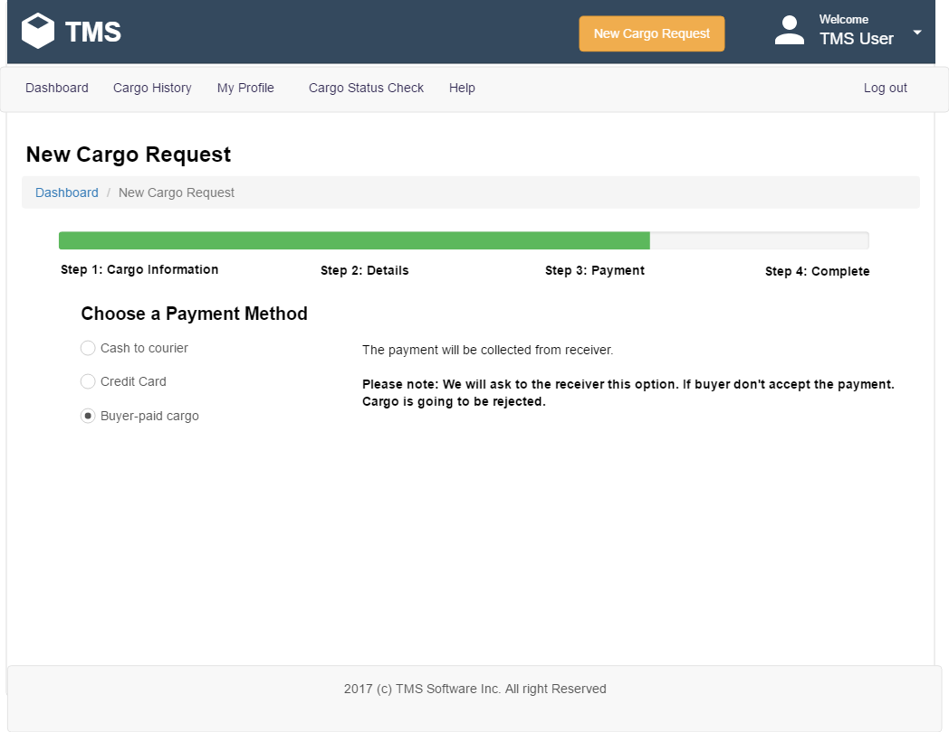

|  |  |
| --- | --- |
| Name of the Item: | Previous Button |
| Description of Purpose: | Go to Step 2: Details Tab. |
| Source of Input: | Mouse |

|  |  |
| --- | --- |
| Name of the Item: | Next Button |
| Description of Purpose: | Go to Step 4: Confirm Tab. |
| Source of Input: | Mouse |

##### Cargo Request: Confirm Page

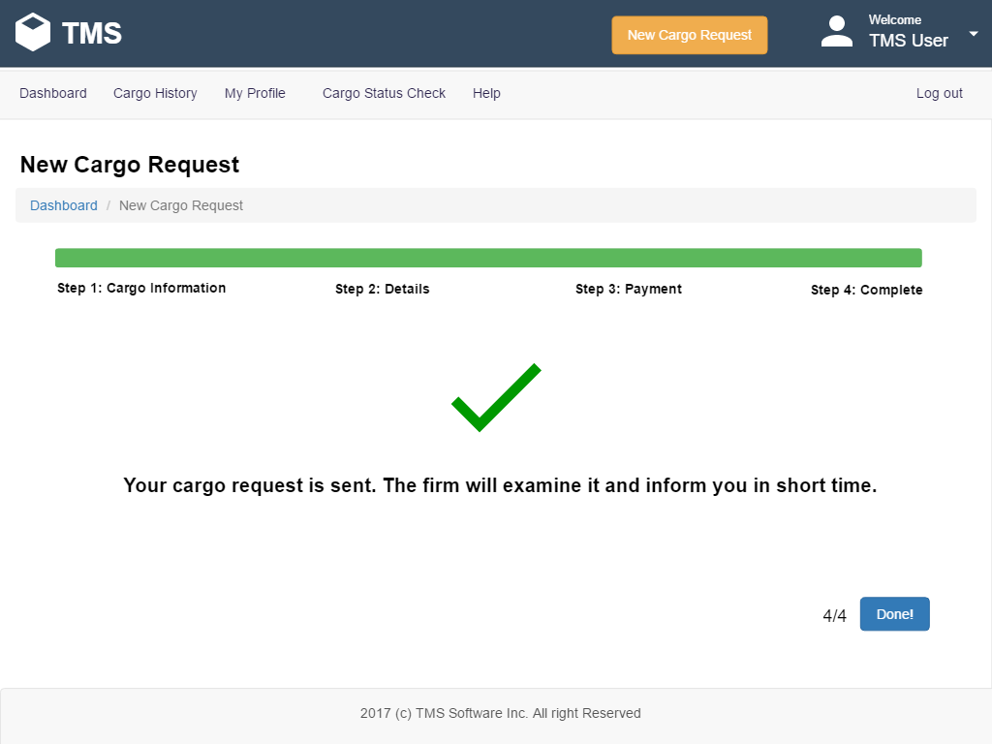

|  |  |
| --- | --- |
| Name of the Item: | Done! Button |
| Description of Purpose: | Complete the request and back to the Cargo Details |
| Source of Input: | Mouse |

##### Cargo Status Check Page

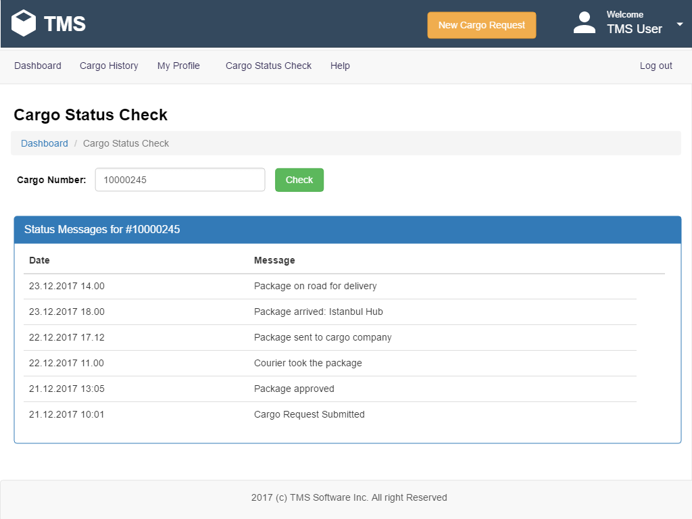

|  |  |
| --- | --- |
| Name of the Item: | Cargo number Textbox |
| Description of Purpose: | To enter the number of the cargo |
| Unit of Measure: | Character |
| Source of Input: | Mouse and Keyboard |
| Relationship to other Inputs/Outputs: | It is an input for Cargo Status Check |

|  |  |
| --- | --- |
| Name of the Item: | Check Button |
| Description of Purpose: | Check cargo status for Cargo number textbox given number. |
| Source of Input: | Mouse |

##### Help Page

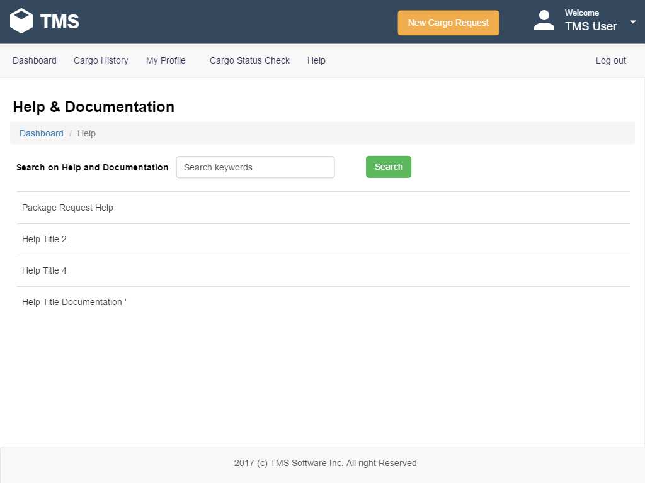

|  |  |
| --- | --- |
| Name of the Item: | Search Keyword textbox |
| Description of Purpose: | Help Subject for the search on help file. |
| Unit of Measure: | Character |
| Source of Input: | Mouse and Keyboard |
| Relationship to other Inputs/Outputs: | Help search input and output is help page |

|  |  |
| --- | --- |
| Name of the Item: | Search Button |
| Description of Purpose: | Search help index for given keyword. |
| Source of Input: | Mouse |

|  |  |
| --- | --- |
| Name of the Item: | Search Subject Tables |
| Description of Purpose: | Search Result for the keyword list. Click and read details. |
| Source of Input: | Mouse |

#### System Administrators Pages

Will be completed on next sprint.

#### General Manager Pages

Will be completed on next sprint.

#### Middle-Level Management Operational Pages

Will be completed on next sprint.

### 3.1.2. Hardware Interfaces

The hardware interfaces defined by 2.1.3 shall be implemented. No other specific hardware interfaces are required.

### 3.1.3. Software Interfaces

The software interfaces defined by 2.1.4 shall be implemented. No other specific software interfaces are required.

### 3.1.4. Communication Interfaces

The communication interfaces defined by 2.1.5 shall be implemented. No other specific communication interfaces are required.

## Functional Requirements

Use Cases are used to define specific requirements in this section and functional requirements are stated by use case scenarios of use case diagrams.

### User Class 1 – All Users

This section describes the functional requirements used by all users of the system. The usage status of the system is as follows. This usage diagram for the overall appearance of the system. Detailed system functions are explained in the next user classes.

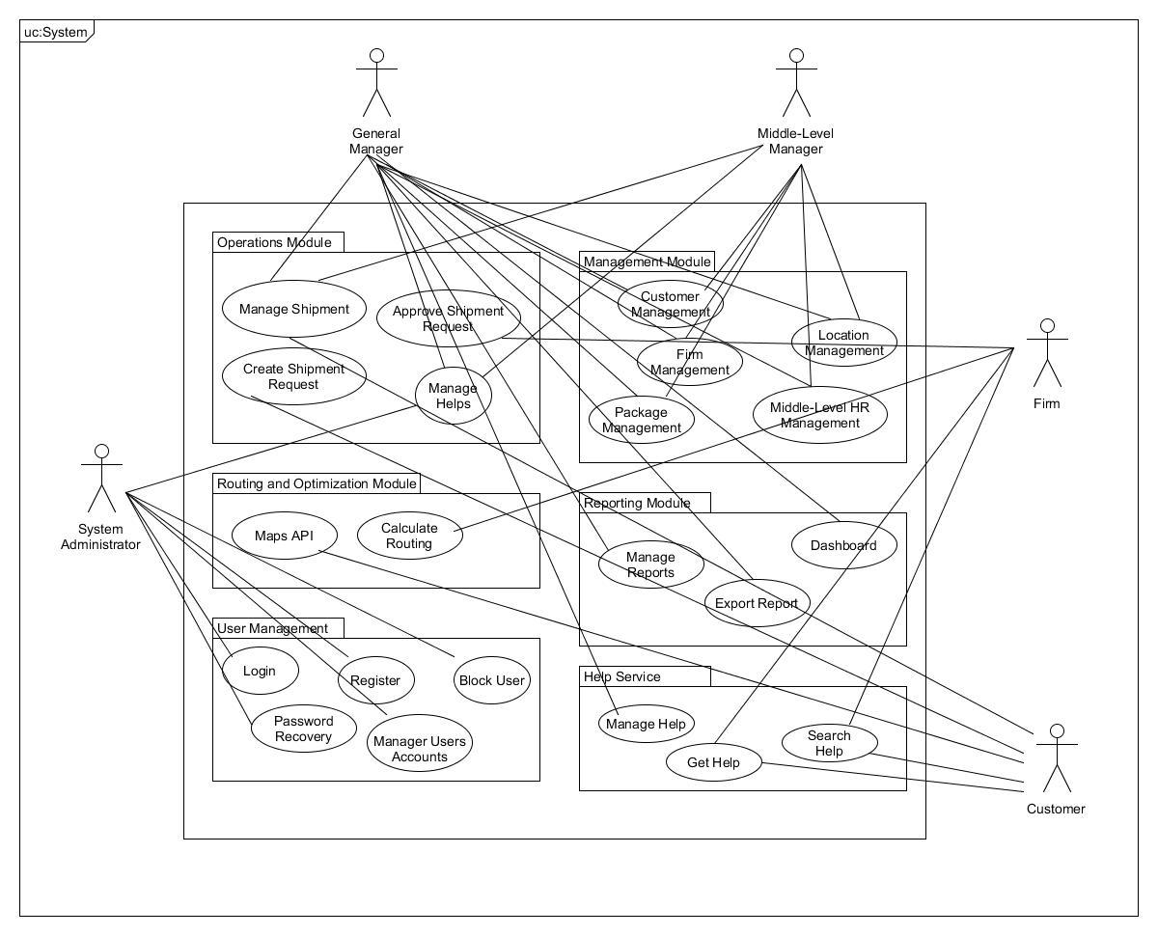

*Figure 3 Use Case TMS*

### User Class 2 – Player

### User Class 3 – Content Editor

### User Class 4 – Administrators

### User Class Scenarios

#### 3.2.2.1 User Class Scenario for Registration, Login and Recovery Password Operations

|  |  |
| --- | --- |
| Use Case ID: | UC-C-1 |
| Use Case Name: | Create New Account |
| Actor(s): | Player, Content Editor, Administrator |
| Goal: | To create new account for the player |
| Trigger: | Request of the user to create new account |
| Preconditions: | Access to Google Play Game Service |
| Normal Flow: | ***Actor:***   1. Click the “Sign Up” button   ***System:***   1. Direct the user to “Google Account Sign Up” page or Sign Up with Directly   ***Actor:***   1. Select Google account or player name and password.   Click the “Sign me Up!” button  ***System:***   1. Display the “registration completed” message |
| Alternative Flows: | ***Actor:*** |
| Post Condition: | Sign up is successfully This Player name is already using, please change the username. |
| Business Rules: | The user has to enter all mandatory fields |

#### 3.2.2.2 Login

|  |  |
| --- | --- |
| Use Case ID: | UC-C-2 |
| Use Case Name: | Login |
| Actor(s): | Customer, Content Editor, Administrator |
| Goal: | Authorize the user on the system |
| Trigger: | Create new session |
| Preconditions: | Actor should not have logged in to the system |
| Normal Flow: | ***Actor:***   1. Click the “Login” button on the main page   ***System:***   1. Show user “Login” page   ***Actor:***   1. Enter email address and password. 2. Click the “Login” button   ***System:***   1. Match username and password on the database 2. If step 5 is true: Redirect to the user dashboard |
| Alternative Flows: | ***System:***   1. If step 5 is false: Show login_error message and redirect to login 2. Continue to step 3. 3. Connect directly google play game service. |
| Post Condition: | Redirect to dashboard |
| Business Rules: | The user must enter all mandatory fields |

***3.2.2.3 Forgotten Password***

|  |  |
| --- | --- |
| Use Case ID: | UC-C-3 |
| Use Case Name: | Forgotten Password |
| Actor(s): | Customer, Firm, Content Editor, Administrator |
| Goal: | To recovery the forgotten password |
| Trigger: | - |
| Preconditions: | Not logged to the system |
| Normal Flow: | ***Actor:***   1. Click the “Login” button on the main page   ***System:***   1. Show user “Login” page   ***Actor:***   1. Click “Forgot password” link   ***System:***   1. Show user “Forgot password” page   **Actor:**   1. Enter the “email address” 2. Click “Submit” button   **System:**   1. Send recovery mail 2. Show “Forgot Password Confirm” Page   **Actor:**   1. Click “go to login” button |
| Alternative Flows: |  |
| Post Condition: | Should be create password recovery key |
| Business Rules: | The user must enter email fields |

***3.2.2.4 Use Class Scenario for Create Character***

|  |  |
| --- | --- |
| Use Case ID: | UC-C-4 |
| Use Case Name: | Create Character |
| Actor(s): | Player |
| Goal: | To create character which will play |
| Trigger: | - |
| Preconditions: | Not logged to the system |
| Normal Flow: | ***Actor:***   1. Click the “Create Character” button on the character page   ***System:***   1. Show the character types 2. Chose gender 3. Chose physical appearance   ***Actor:***   1. User will chose character type one of “wizard, warrior, healer, etc(will be change soon) 2. Gender optimized the character 3. Physical appearances optimized the character |
| Alternative Flows: | 1. Random choosing |
| Post Condition: | Should be created character |
| Business Rules: | The user must click create |

#### 

#### 3.2.2.5 User Class Scenario for Fight Requests

|  |  |
| --- | --- |
| Use Case ID: | UC-C-4 |
| Use Case Name: | Fight |
| Actor(s): | Player |
| Goal: | Fight with mob |
| Trigger: | Request of the actors to fight a mob that given by player to mobile applications |
| Preconditions: | Player already has a character |
| Normal Flow: | **Actor:**   1. Fight or not with the chosen mob.   **System:**   1. Displays mob names and number 2. Displays mobs qualification.   **Actor:**   1. Sees the mobs list against player   **System:**   1. Displays fight or retreat button   **Actor:**   1. Click fight button   **System:**   1. War scene will open   **Actor:**   1. Click retreat button   **System**:   1. Go back the map |
| Alternative Flows: | **Actor:**   1. Fight with friends(will be soon) |
| Post Conditions: | Complete first match. |
| Business Rules: | --- |

***3.2.2.6 Time to fight use case***

|  |  |
| --- | --- |
| Use Case ID: | UC-C-5 |
| Use Case Name: | Fight Moment |
| Actor(s): | Player |
| Goal: | Actions against enemy |
| Trigger: | Decide to attack |
| Preconditions: | To attack enemy mob |
| Normal Flow: | **Actor:**   1. Attack   **System:**   1. Hit to the mob   **Actor:**   1. Defence yourself   **System:**   1. Increase instant defence point   **Actor:**   1. Retreat   **System:**   1. Escape from fight   **Actor:**   1. Access inventory   **System:**   1. Inventory is open |
| Alternative Flows: |  |
| Post Conditions: | --- |
| Business Rules: | --- |

#### 3.2.2.7 Player’s Inventory

|  |  |
| --- | --- |
| Use Case ID: | UC-C-6 |
| Use Case Name: | Reach the inventory |
| Actor(s): | Player |
| Goal: | To open inventory |
| Trigger: | Request for the actors to access inventory |
| Preconditions: | Inventory must be closed |
| Normal Flow: | **Actor:**   1. Wear item   **System:**   1. If wearing slot is empty item will be wear.   **Actor:**   1. Delete item   **System:**   1. Item dissapear   **System**:   1. Use item   **Actor:**   1. If item is usable, item will use.   **System:**   1. Close inventory   **Actor:**   1. Inventory tab will closeç |
| Alternative Flows: | **---** |
| Post Conditions: | --- |
| Business Rules: | --- |

#### User Class Scenario for Change Profile Settings

|  |  |
| --- | --- |
| Use Case ID: | UC-C-7 |
| Use Case Name: | Profile Settings |
| Actor(s): | All Users |
| Goal: | Change Profile Setting Successfully |
| Trigger: | - |
| Preconditions: | Actor should have logged in |
| Normal Flow: | ***Actor:***   1. Go to Profile Settings Page   ***System:***   1. Show “Profile Settings”   ***Actor:***   1. Fill fields that want to change. 2. Click Save   ***System:***   1. Show profile settings changed successfully message |
| Alternative Flows: |  |
| Post Condition: | User shall see updated information on the fields. |
| Business Rules: | Required fields shall not be left empty. |

|  |  |
| --- | --- |
| Use Case ID: | UC-C-7.1 |
| Use Case Name: | Change Password |
| Actor(s): | All Users |
| Goal: | Change actor’s current login password |
| Trigger: |  |
| Preconditions: | Actor should be logged on the system |
| Normal Flow: | ***Actor:***   1. Go to Profile Settings Page   ***System:***   1. Show “Profile Settings”   ***Actor:***   1. Fill change password section, new password and password confirm. 2. Press submit button   ***System:***   1. Show Password changed successfully message |
| Alternative Flows: | **System:**  5a. Show “This password is not valid for the system” message  **Actor:**  Go Step 3. |
| Post Condition: |  |
| Business Rules: |  |
|  |  |

#### User Class Scenario for Logout

|  |  |
| --- | --- |
| Use Case ID: | UC-C-9 |
| Use Case Name: | Logout |
| Actor(s): | All Users |
| Goal: | To log out from the system |
| Trigger: | Close session |
| Preconditions: | Should be logged in to the system |
| Normal Flow: | ***Actor:***   1. Click the Logout button   ***System:***   1. Send to Login page |
| Alternative Flows: | - |
| Post Condition: | Session should be cleared. User should redirect to the login page |
| Business Rules: | - |

#### User Class Scenario for Map Interactions

|  |  |
| --- | --- |
| Use Case ID: |  |
| Use Case Name: | Choose Places from Map |
| Actor(s): | All users |
| Goal: | See feature what is clicked |
| Trigger: | Request to learn what is on the screen |
| Preconditions: | Map should be open |
| Normal Flow: | ***Actor:***   1. Click on the things   ***System:***   1. Show the feature what is clicked |
| Alternative Flows: | ***System:*** If no location is chosen show “Please select at least two locations” message. |
| Post Condition: |  |
| Business Rules: | The user has to choose at least two places |

#### User Class Scenario for Content Editors Operations

#### User Class Scenario for Administrator Operations

#### User Class Scenario for Reporting

## Performance requirements

Some Performance requirements identified is listed below:

* The maximum number of simultaneous users required to be supported by the system shall be 50.
* The database shall be able to accommodate a minimum of 10,000 records of gamers.
* The software shall support use of multiple users at a time.
* There are no other specific performance requirements that will affect development.
* The user shall able to login to the system in 4 seconds.
* The system shall display each page in 5 seconds.
* The system shall render each report in 8 seconds.
* 95% of the transactions shall be completed under 5 seconds.

## Logical Database Requirements

Data entities and their relationships are shown in the ER diagram in Appendixes.

## Design constraints

The design shall be per IEEE Standard 1016-1998 Recommended Practice for Software Design Descriptions.

### Standards compliance

This subsection should specify the requirements derived from existing standards or regulations. They may include the following:

#### Report Format

The system shall generate reports in a standard format which consist of header and body parts.

Header part includes, logo of TMS, reporting date and time. Body part is composed of reporting details. Sample reports are shown in Appendixes.

## Software system attributes

This section provides non-functional requirements for the software system.

### Reliability

* System's meantime between failures will be 15 days.

### Availability

* The system shall be available in 4 hours after operating system crash.
* The system shall be available in 4 hours after a database crash.
* The system shall be available in 2 hour after application server crash.
* The system shall work 85% of the time in one year.

### Security

* The system shall authorize user from the login screen with email address and password.
* The system shall store password with MD5 Hash rather than direct password value.
* The system shall keep logs for login and logout operations and other transactions at the application server and store for 1 year.
* Transaction management will be managed considering ACID principle.
* The system shall allow password that are at least 5 (five) characters long.
* The System shall mask the password fields in the login screen.
* The system shall have automatic log out.
* The session time of the system shall be 20 (twenty) minutes.
* The system doesn’t allow any type of file upload.

### Maintainability

* Writing comments between programming code parts shall be used to help editing the codes during maintenance.
* Class Diagrams and design patterns reduce the maintain effort.
* System maintenance shall be done once a year.

### Portability

* The application will work any JAVA EE supported platforms and 100% of the components are portable.
* The application will be accessible any place that have internet connection.

# Appendixes

## Appendix A: Routing Optimization in Transportation Management System

#### Travellıng Salesman Problem

It is an NP-hard problem in combinatorial optimization, important in operations research and theoretical computer science. TSP is a special case of the travelling purchaser problem and the vehicle routing problem. In the theory of computational complexity, the decision version of the TSP (where, given a length L, the task is to decide whether the graph has any tour shorter than L) belongs to the class of NP-complete problems. Thus, it is possible that the worst-case running time for any algorithm for the TSP increases superpolynomially (but no more than exponentially) with the number of cities. (Wikipedia)

#### Maps and Directions

This map will show up when the customer selects cities and wants to learn about which route his/her cargo will reach to the destination. In other part the transporter can see on which route he can travel to distribute that given cargos. On technical perspective in order to create this, a Javascript library called d3.js is used to draw the map. The coordinates of the cities has been taken from geojson file.

In order to route between cities , the program retrieves the city coordinates from database and routes between them using travelling salesman problem. In this last version Google maps directions api is integrated to show the directions of the roads. Also, it is colored by the importance of the destinations. *Please click on this website to see last changes for demo : samplemap.000webhostapp.com*

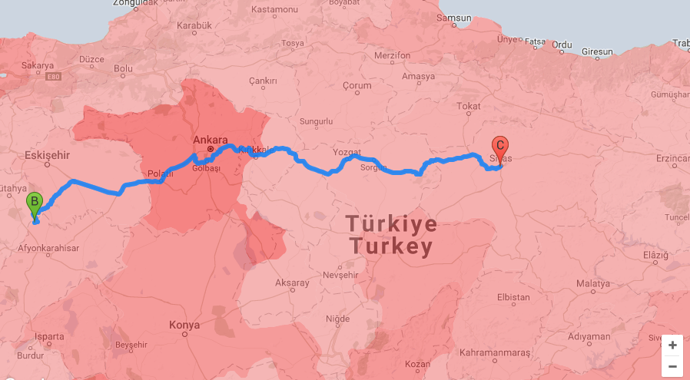

*Figure 4 Two location routing*

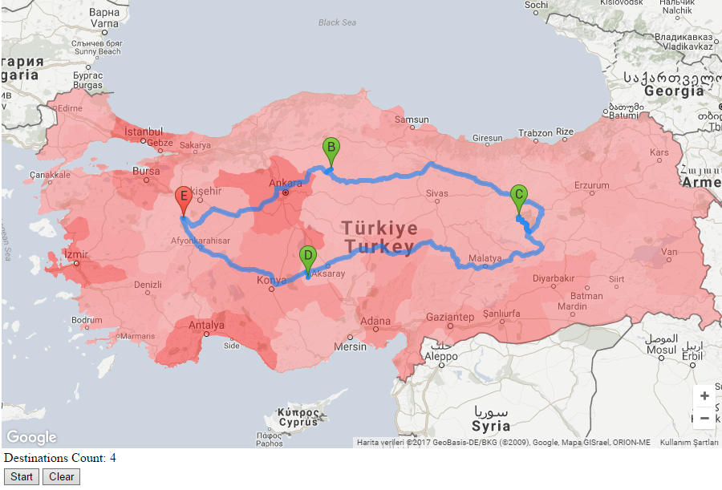

*Figure 5 Multiple location routing*

## Appendix B: ER Diagram